DISHES AND THEIR ALLERGEN CONTENT A LA CARTE MENU

DISHES | 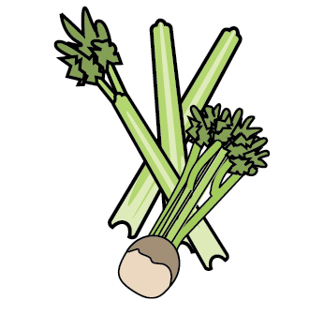 |  | 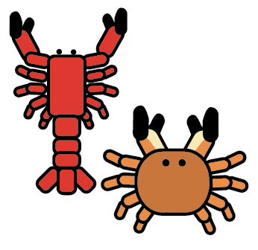 |  |  |  |  |  |  | 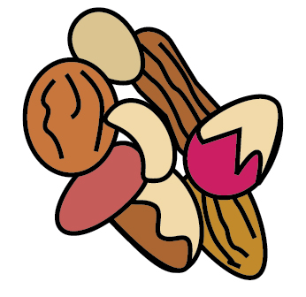 | 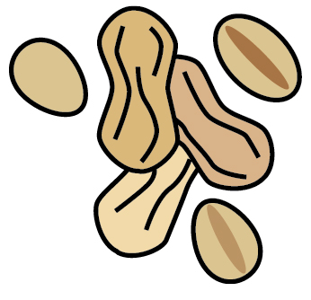 | 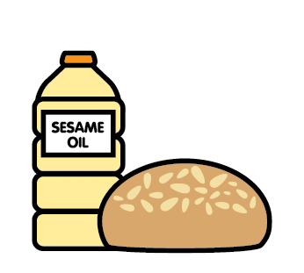 |  | 
 | Celery | Cereals containing gluten | Crustaceans | Eggs | Fish | Lupin | Milk | Mollusc | Mustard | Nuts | Peanuts | Sesame seeds | Soya | Sulphur Dioxide
Soup |  | ✓ |  |  |  |  | ✓
Cod Fillet |  | ✓ |  | ✓ | ✓ |  |  |  |  |  |  |  |  | ✓
Duck Bon Bons |  | ✓ |  | ✓ |  |  | ✓ |  |  |  |  |  | ✓
Ham Hock |  | ✓ |  |  |  |  | ✓ |  | ✓
Tempura Prawns |  | ✓ | ✓
Scallops |  |  |  |  |  |  |  | ✓
Beetroot & Goats Cheese Carpaccio |  | ✓ |  |  |  |  | ✓ |  | ✓
Chicken Supreme |  |  |  |  |  |  | ✓
Lamb Rump |  |  |  |  |  |  | ✓
Beef Bavette Steak |  |  |  | ✓ |  |  | ✓ |  | ✓
Pork Fillet |  |  |  |  |  |  | ✓ |  |  |  |  |  |  | ✓
Dover Sole |  |  |  |  | ✓ |  | ✓
Prawn & Salmon Linguine |  | ✓ | ✓ |  | ✓ |  | ✓
Risotto |  |  |  |  |  |  |  |  |  |  |  |  | ✓
Margherita Pizza |  | ✓ |  |  |  |  | ✓
Pepperoni Pizza |  | ✓ |  |  |  |  | ✓
Hawaiian Pizza |  | ✓ |  |  |  |  | ✓
Gammon Steak |  | ✓ |  | ✓
Sirloin Steak |  | ✓ |  |  |  |  | ✓ |  | ✓
Beef Burger |  | ✓ |  | ✓ |  |  | ✓ |  | ✓ |  |  |  | ✓
Chicken Caesar Salad | ✓ | ✓ |  | ✓ | ✓ |  | ✓ |  | ✓ |  |  |  | ✓
Caesar Salad | ✓ | ✓ |  | ✓ | ✓ |  | ✓ |  | ✓ |  |  |  | ✓
Halloumi Burger |  | ✓ |  | ✓ |  |  | ✓ |  | ✓ |  |  |  | ✓
Baileys Cheesecake |  | ✓ |  | ✓ |  |  | ✓ |  |  | may | may |  | ✓ | ✓
Au Chocolate |  | ✓ |  | ✓ |  |  | ✓ |  |  | may | may |  | ✓
Fruit Pavlova |  |  |  | ✓ |  |  | ✓
Cheese Plate | ✓ | ✓ |  |  |  |  | ✓
Ice Creams |  |  |  |  |  |  | ✓ |  |  |  |  |  | ✓
Fruit Salad
Chunky Chips |  | ✓
French Fries |  | ✓
Onion Rings |  | ✓
Seasonal Vegetables
Cheesy Garlic Bread |  | ✓ |  |  |  |  | ✓
Side Salad

Review date:28.07.2023 |  | Reviewed by: | Chef |  | You can find this template, including more information at www.food.gov.uk/allergy

